Unit 21: Charity Funding Predictor

**Overview**

The nonprofit foundation Alphabet Soup wanted a tool that can help it select the applicants for funding with the best chance of success in their ventures. With my knowledge of **machine learning and neural networks**, I used the features in the provided charity_data.csv dataset to create a binary classifier that predicted whether applicants will be successful if funded by Alphabet Soup.

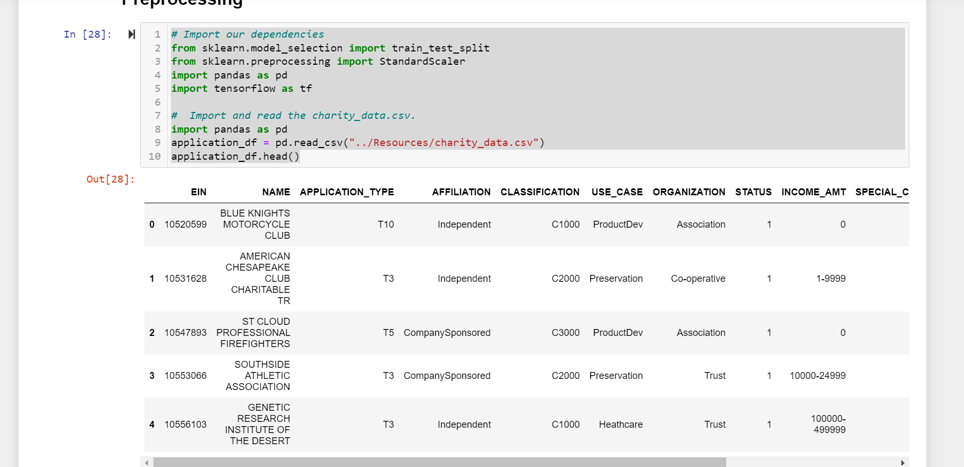

**Results**

**Data Processing: We first started by reading the file into jupyter notebook and determined which variables were targets and features for our model. We dropped columns ‘EIN’ and ‘Name’ to give us the main features for our model. We determined data points for each unique value for columns that had more than 10 unique values. Our next step was to pick a cut off point to bin categorical variables together the the value “other” and then check if it was successful for the next stage. We finally used pd.get_dummies() to encode categorical variables.**

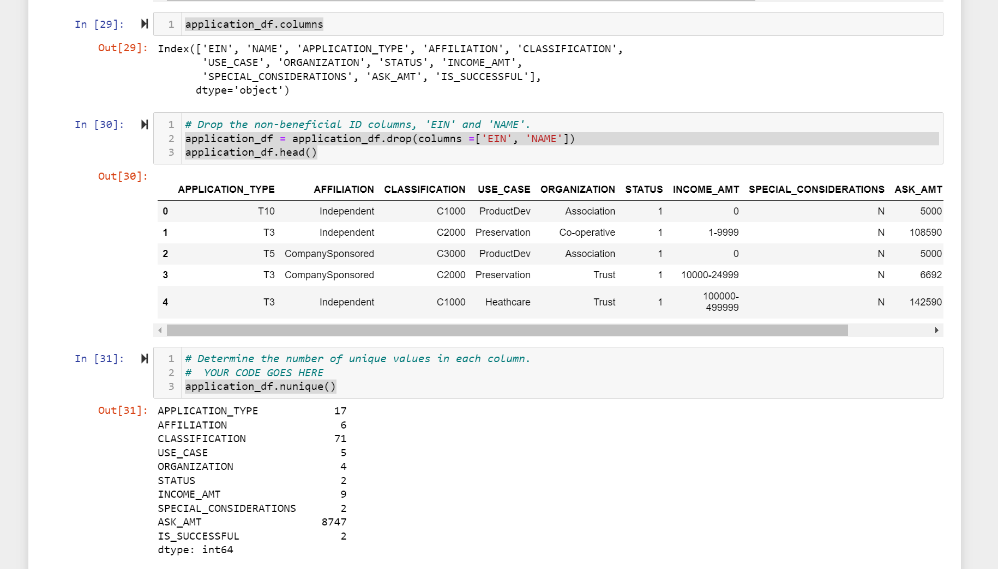

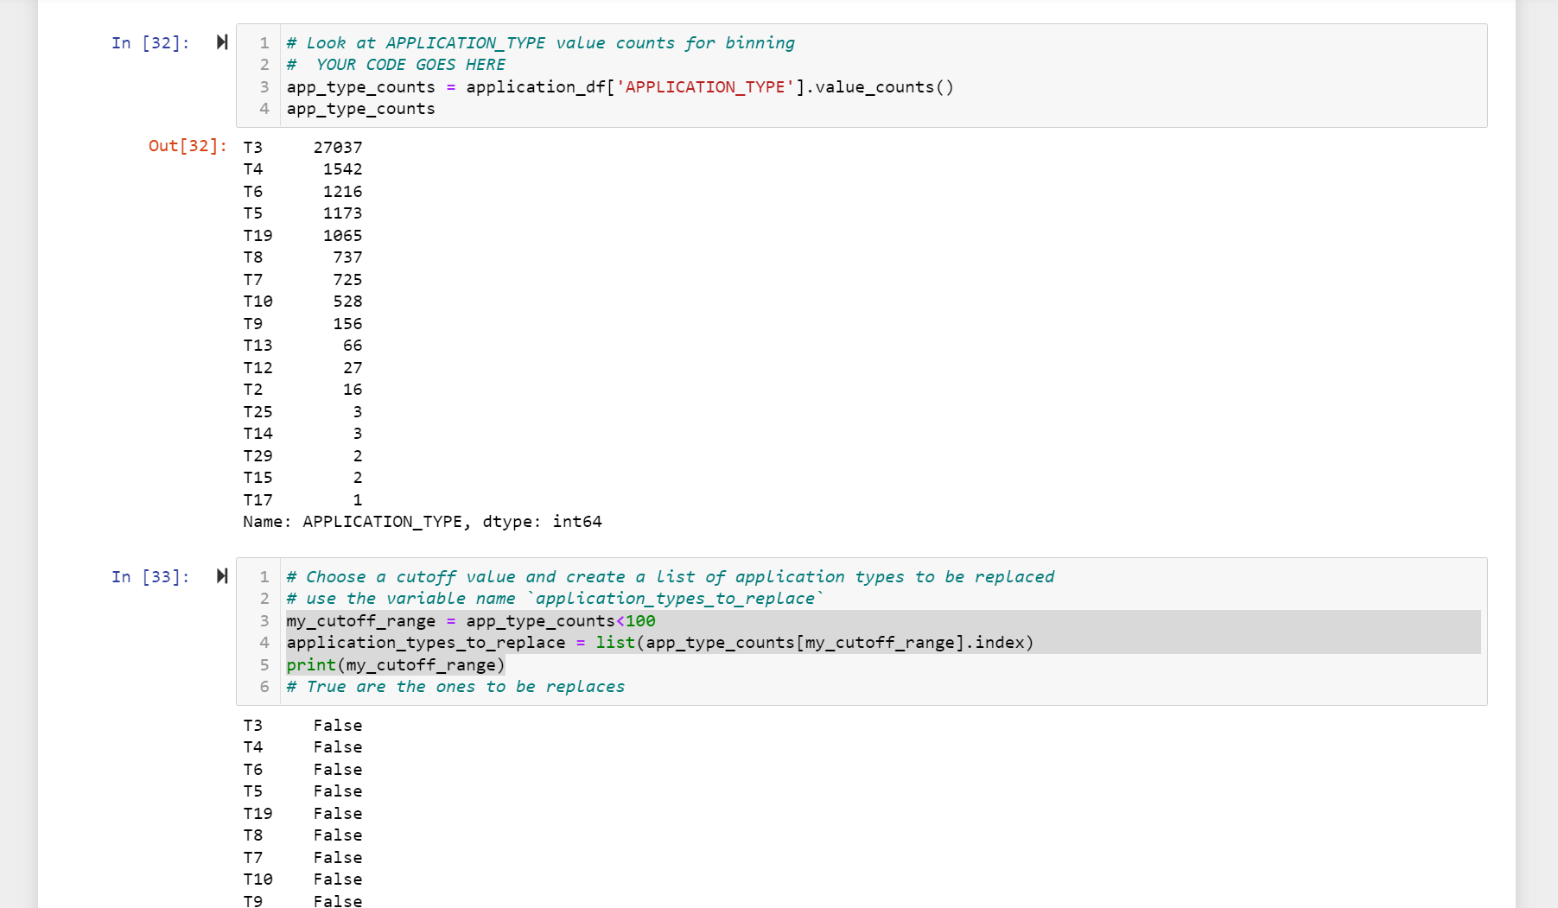

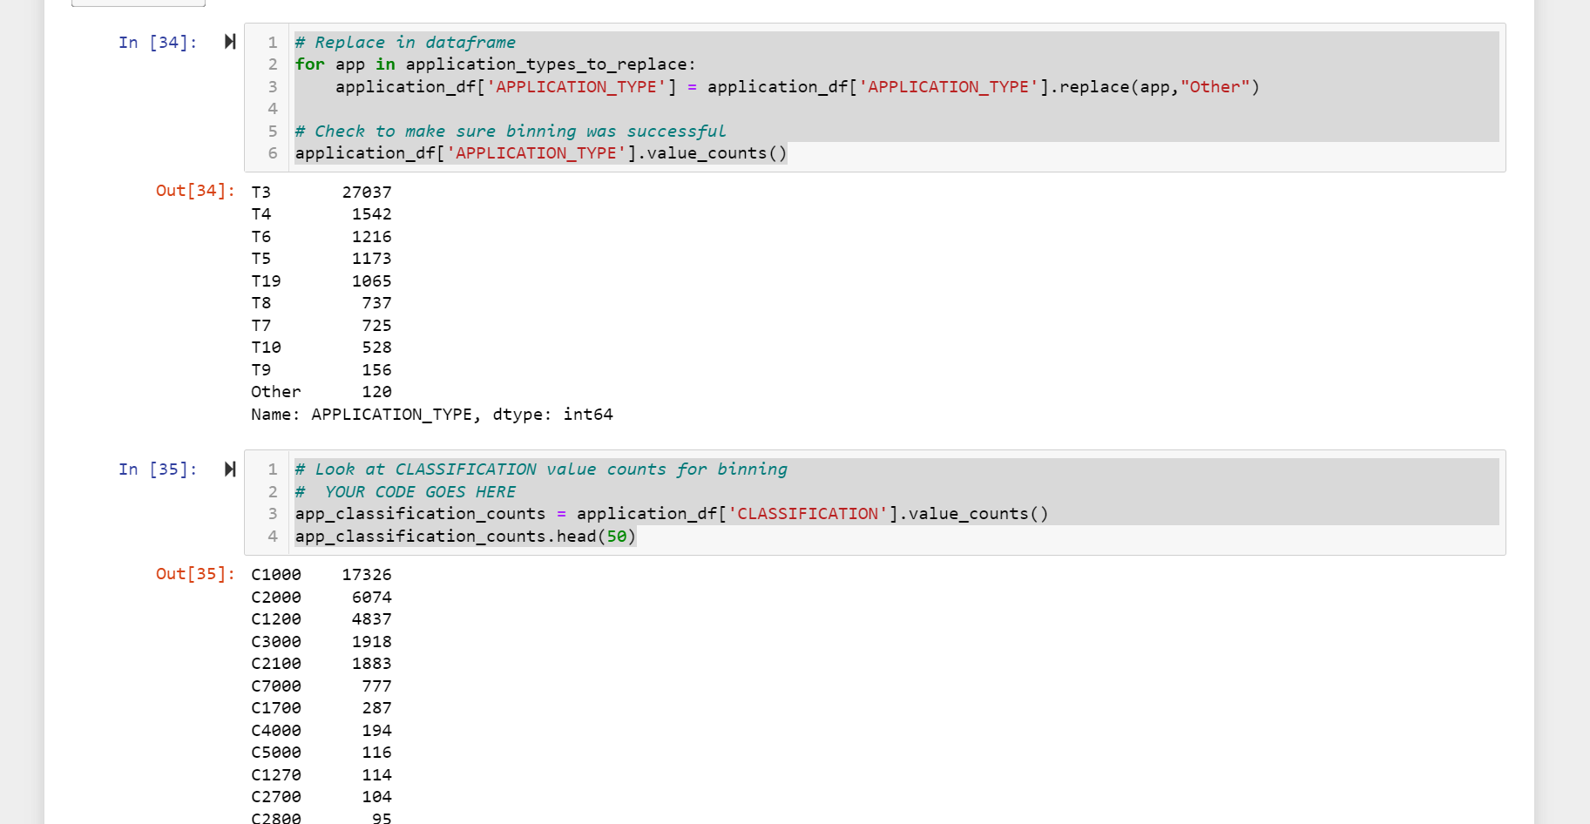

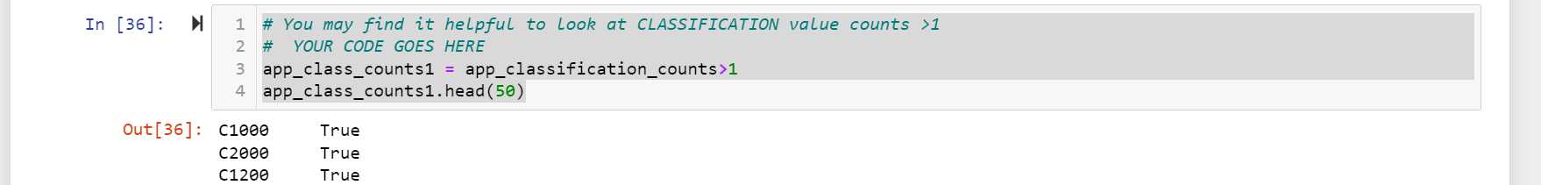

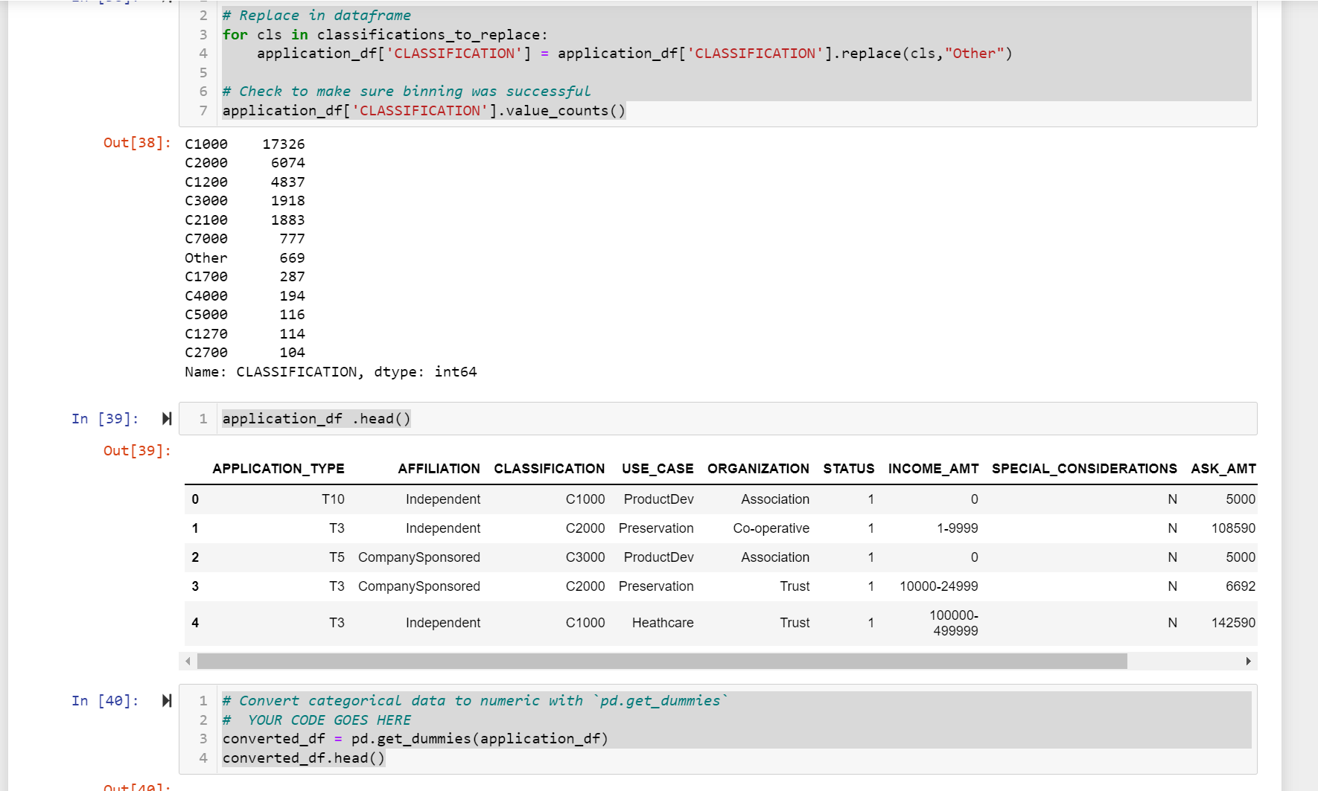

**Compiling, Training and Evaluating the Model: Using TensorFlow, I designed my model to create a binary classification model. This allowed it to predict if any organisation funded by this organisation will be successful or not based on the features of the dataset.**

**The number of neurons and layers were determined in the model. After these steps, I compiled, trained and evaluated the binary classification model to calculate the models loss and accuracy.**

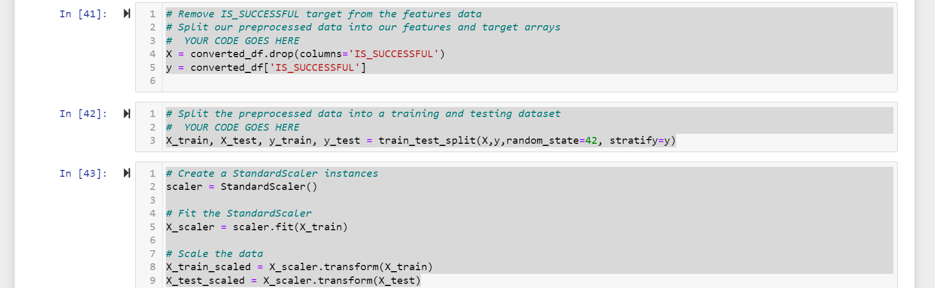

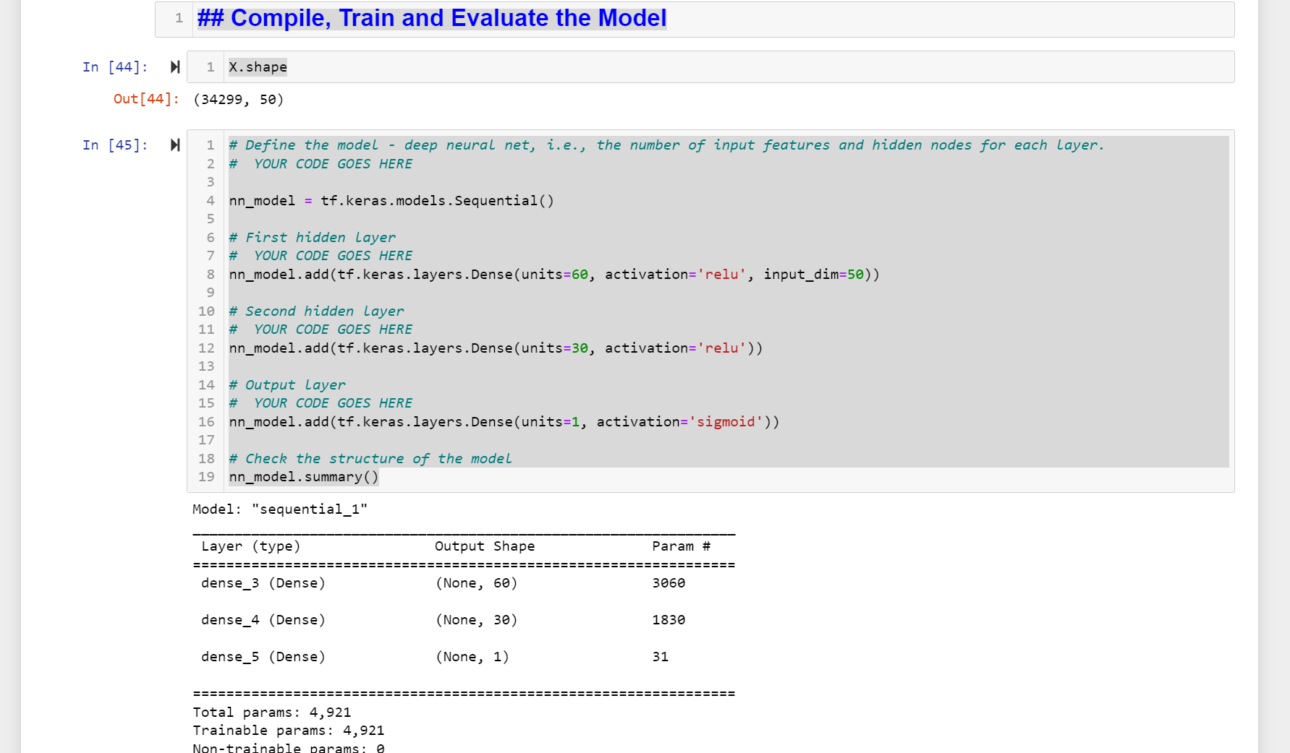

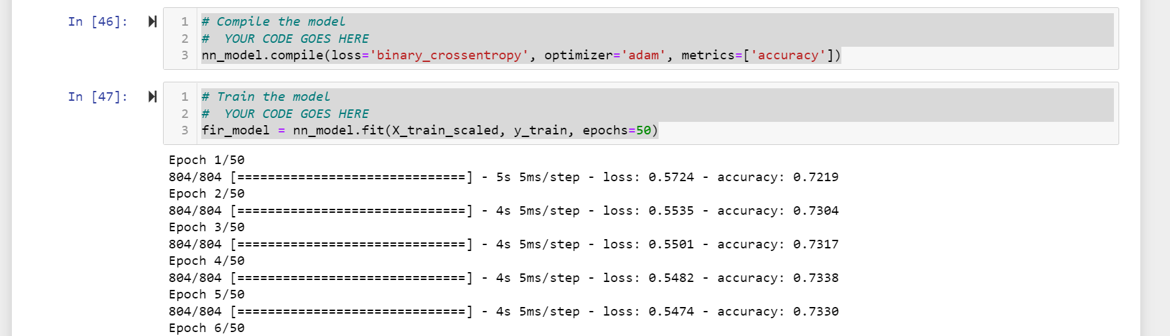

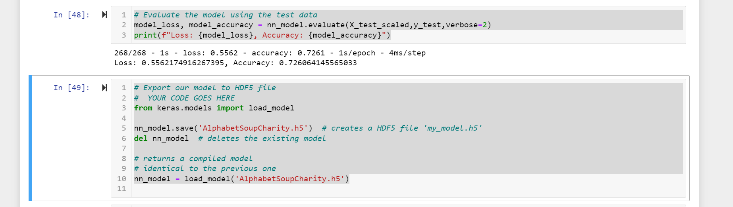

We then went on to optimize our model by removing 1 column rather than 2 columns to improve our model, potentially. The aim was to achieve 75% rather than the 72% had in my first model.I also increased more nodes and the initial was more this time round, from 50 to 88! Finally I increased the epochs to test if it improves the model but it peaked immediately.



